8,8 or 22/25

Assignment # 2 in Rstudio

Margrét Brynja Guðmundsdóttir

PRMA

Reykjavík University

**Question 1 - Item Response Functions and Person Estimates**

**(a) Which item was the easiest item and which item was the hardest? (2 points)**

Item 5 was the easiest (with difficulty of -1.626), and item 10 was the hardest item (with difficulty of 0.53).

**(b) Provide a 95% confidence interval for the easiest item and interpret it. (2 points)**

SE: 0.132

Point estimate: -1.626

-1.626 + 1.96 * 0.132 = -1.367

-1.626 – 1.96 * 0.132 = -1.884

I am 95% confidant that the true item difficulty lays between -1.367 and -1.884. -.5

**(c) Provide a plot that contains both the easiest and the hardest item. (1 point)**

Plot for the hardest item (item 10):

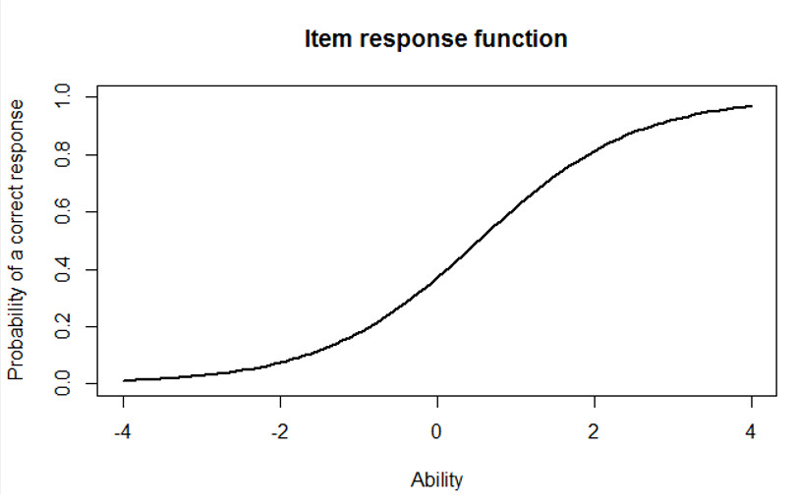

Plot for the easiest item (item 5):

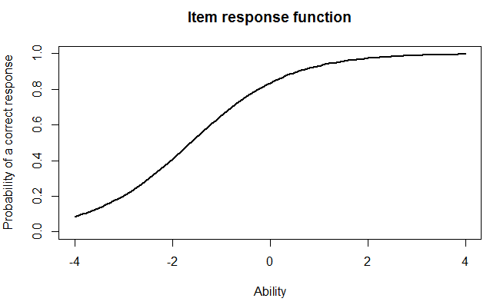

**(d) What would we expect the probability of a correct response to be for someone who had an ability score of 0 for these two items? (2 points)**

The probability for someone to get a correct response on item 10 is 0.4.

The probability for someone to get a correct response on item 5 is 0.8.

**(e) What was the score of the person who did the best on the test? What was the score of the person who did the worst on the test? (2 points)**

The score of the person that did the best on the test was 393. The score of the person that did the worst on the test was 49.

**(f) Provide a 95% confidence interval for the estimated ability for the student who did the best on the test and interpret it. (2 points)**

SE: 2.204

Point estimate: 3.999

3.999 + 1.96 * 2.204 = 8.318

3.999 – 1.96 * 2.204 = -0.320

I am 95% confidant that the true ability of the student lays between. -0.320 and 8.318. -.5

**Question 2 - For this question, you will choose three items to investigate.**

**(a) Please state the three items you selected. (1 point)**

Items 8, 11, and 14.

**(b) Provide a plot that contains these three items’ information functions. (1 point)**

The plot for the three items:

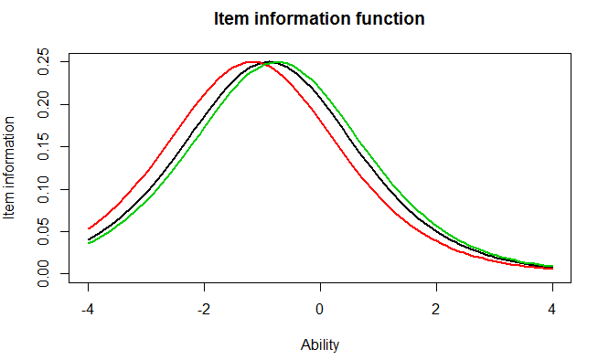

**(c) What is the same about these items’ information functions? What is different? Hint: This can be a very short answer. (2 point)**

The items are all similarly difficult, are highly discriminating (just like the assumption that items have the same discrimination power) and the scale score ranges of the items are very similar.

One thing that differs the items is that the ability levels are centered at slightly different spots (the black item is centered at approximately -1 while the red item is centered at approximately -1.5). Therefore they differ by item difficulty.

**(d) Provide a plot of the test information function. (1 point)**

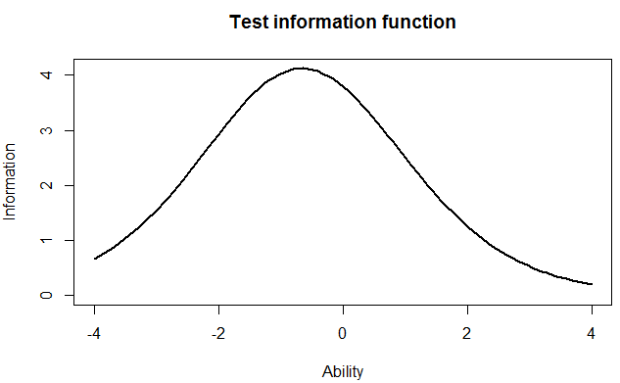

**(e) Where is the majority of the information for this test located? (1 point)**

The majority of the information for this test is located between -2 and 0, peaking at approximately 0.8.

**Question 3 - Comparing the 2-PL;**

**(a) Which item had the highest discrimination? Which one had the lowest discrimination? (2 point)**

Item 8 had the highest discrimination (2.88) and item 12 had the lowest discrimination (0.332).

**(b) Are the items that were the easiest and hardest in the Rasch model, also the easiest and hardest in the 2-PL? (1 point)**

No. This time, item 1 is the easiest (item 5 was the easiest in the Rasch model), but item 10 is again the hardest item, just like in the Rasch model.

**(c) What is the correlation between the ability estimates on the Rasch model and the 2-PL?**

The correlation is 0.97.

**If your interest was solely on estimating person abilities, do you think you would draw the same conclusions from both models? Why? (2 point)**

No. Item discrimination is a part of the 2-PL model, which separates people with higher or lower abilities (Cohen, Swerdlik, & Phillips, 1996, p. 169). I would therefore consider the 2-PL model to be more suitable and rather use it because I could discriminate people, but the Rasch model would be competent regarding the measurement of ability.

But the correlations is so high between these two. That means that people that were estimated to have a high score on the Rasch will also get a high score on the 2PL and therefore end up with the same conclusions. -1

**(d) Provide a plot of the item information function for the three items you selected in Question 2 but this time for the 2-PL model. (1 point)**

The plot for items 8, 11 and 14:

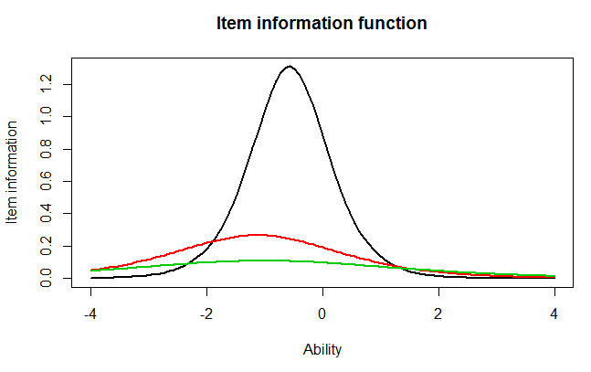

**(e) For the 2-PL model, how do the item information functions for these items differ?**

The corresponding item information functions for the red and green items are less discriminating and lower (provide less information) than for the black item. The item information functions therefore differ by item discrimination. They also differ by item difficulty, the red and green items have a low item information value, especially compared to the black item. The black item is steeper and better at predicting for persons scoring in that range.

**How do the 2-PL item information functions from these items differ from their Rasch item information functions? (2 point)**

The Rasch model does not provide item discrimination like the 2-PL IRT model does. Therefore, the 2-PL item information functions provide more information than the Rasch information functions. the items in the Rasch are more discriminating for the green item. The shape is affected by discriminating and the center by item diffiuculty. -1

References

Cohen, R. J., Swerdlik, M. E., & Phillips, S. M. (1996). *Psychological testing and assessment: An introduction to tests and measurement (3rd ed.)* (Vol. xxviii). Mountain View, CA, US: Mayfield Publishing Co.